

**Aqaba University of Technology**

**Faculty of Information Technology**

**Department of Software Engineering**

Job Candidate System (JCS)

**By**

Hatem Mahmoud AL-Dabet

201510003

**Supervisor**

Dr. Basem Zughoul

**A graduation Project Submitted in Partial Fulfillment of the Requirements for the BSc in Software Engineering**

January, 2019

# Acknowledgments

Apart from the efforts of me, the success of this project depends largely on the encouragement and guidelines of many others. I take this opportunity to express my gratitude to the successful completion of this project.

My honor and pleasure thanks to my supervisor and Dean of the Faculty of Information Technology, Dr. Basem Zughoul for his support and assistance in the success of this project.

I would also like to extend my sincere thanks to the members of the discussion committee for their read this modest project and improving it with their valuable guidance.

**Abstract**

Most companies, when announcing new jobs, have difficulty of identifying the right needs due to the large number of applicants and it takes a long time to read and identify the suitable applicant. Therefore, the main objective of the JCS application is to determine the appropriate applicant from all applicants by recognizing each applicant line by line and word by word, then saving the extracted information from all applicants in the database and then organizing the information according to several criteria. The system is implemented through the SQLite database and JetBrains PyCharm IDE. After the system development, it was able to analyze applicants and determine the most suitable candidate for them, based on the number of years of experience and Qualification. This report also discusses each of the underlying technologies used to create and implement the application.

Table of Contents

**Acknowledgments** **i**

**Abstract** **ii**

**Table of Contents iii**

**List of Tables v**

**List of Figures vi**

**List of Appendices vii**

Chapter ONE Introduction 1

1.1 Job candidate process 1

1.2 Job candidate process automation 1

1.3 Problem Statement1

1.4 Project Objectives 2

1.5 Project scope2

1.6 Project plan2

Chapter TWO analysis and design4

2.1 Introduction4

2.2 System analysis and design4

2.3 Requirements Elicitation5

2.4 Process Model6

2.4.1 Functional Decomposition Diagram (FDD)6

2.4.2 Data Flow Diagram (DFD)7

2.5 Use Case Diagram (UCD)8

2.6 Activity Diagram11

2.7 Data Model12

2.7.1 Entity Relationship Diagram (ERD)13

2.7.2 Database Design13

2.8 Sequence Diagram14

2.8.1 Usage and Limitations17

Chapter THREE development and testing19

3.1 Introduction 19

3.2 Software 19

3.3 project process 20

3.4 screens of system 21

3.5 Testing 25

Chapter FOUR conclusion and future work 27

4.1 Conclusion 27

4.2 Future Work27

References 28

List of Tables

2.1 Requirement Elicitation 5

2.2 Use case description10

2.3 APPLICANT 13

2.4 Job14

2.5 Library 14

2.6 users 14

List of Figures

1.1 Gantt chart 3

2.1 Functional Decomposition Diagram 7

2.2 Data flow Diagram 8

2.3 Use Case Diagram 10

2.4 Activity Diagram 12

2.5 JCS ER Diagram 13

2.6 Sequence diagram for signup15

2.7 Sequence diagram for Login16

2.8 Sequence diagram for Add new job16

2.9 Sequence diagram for candidate 17

4.1 Login information screen21

4.2 Main screen22

4.3 personal information screen22

4.4 Applicant screen23

4.5 Jobs screen23

4.6 Add new Job screen24

4.7 JCS screen24

4.8 Setting screen25

4.9 Sign up screen25

List of Appendices

A System screens 29

**Chapter One**

**Introduction**

* 1. **Job candidate process**

Every day, hundreds of thousands of job applications are submitted worldwide, and millions of people apply to them. The traditional method is to nominate the right candidate for the job by read each CV and compare it with the rest of the CVs.

This method may cause major problems, most notably consuming too much time to read each CV and then comparing it to other CVs. It also disables employees from their other business and may not be able to handle thousands of CVs. also CVs can subject to loss, all these and other reasons have made it important to develop a system that resolves this problem.

* 1. **Job candidate process automation**

According to the problems in the job candidate manual process, it is necessary to develop a system capable of solving all these problems by reading all the CVs, extracting the important information and analyzing it and then candidate the appropriate CV according to the analyzed information.

* 1. **Problem Statement**

The problem of determining the suitable candidate for the job was a big problem because the candidates in the appointment of candidates suffer in reading the large number of CVs and compare them and then determine the best, which consumes a lot of time and effort. Therefore, the JCS system helped solve this problem in part by identifying the appropriate candidate from a large number of CVs. The current system has several problems, most notably: Still needs more efficient analysis, it takes a long time for CVs analysis to be absolutely reliable. Also it still needs to increase security.

* 1. **Objectives**

The main objectives of the project is to develop new windows application system that able to:

1. To extract information and analyze in docx and pdf format.
2. To identify and store the analyzed applicants information.
3. To retrieve information based on their qualifications and experiences.
4. To rank the applicants CVs based on prior matching to offered job.
   1. **Project scope**

This application analyzes the job applicant CVs, stores the analyzed information in a database, categorizes it according to the job and the required specializations, and then candidates them and sends a message to the candidate person. This application can accommodate about 1000 CVs, and a person can apply for more than one job within the system. The system can analyze the written CV only in English and in the future work will be supported to be able to analyze different languages and the system will be able to print the names of all applicants with the specified job.

* 1. **Project plan**

Project planning is part of project management, which relates to the use of schedules such as Gantt charts to plan and subsequently report progress within the project environment. A Gantt chart is a type of bar chart that illustrates a project schedule [1]. Figure 1.1 show tasks to be performed and time intervals for each them.

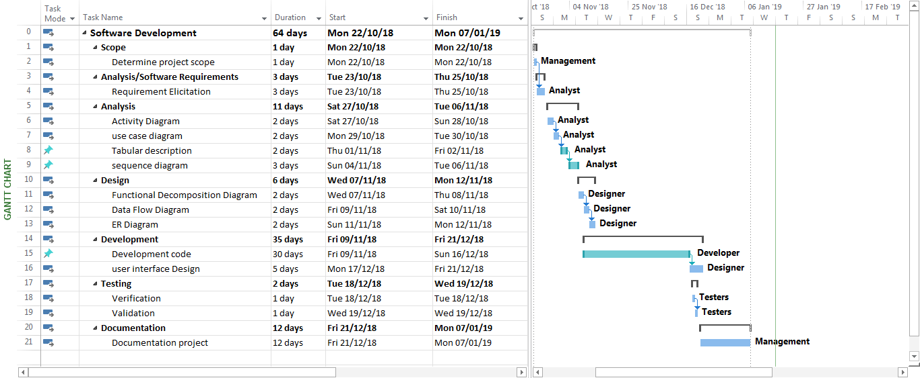

Figure 1.1: Gantt chart for JCS

**Chapter Two**

**Analysis and Design**

* 1. **Introduction**

Systems are created to solve problems or facilitate and improve services. One can think of the systems approach as an organized way of dealing with a problem. In this dynamic world, the subject system analysis and design, mainly deals with the software development activities.

This chapter deals with techniques applied in information system analysis and design, data modeling and normalization. This chapter shows a process or providing full user requirements specification of systems. This specification is also a major information source for designers of the new system. It not only specifies the system's objectives but also describes the work and its constraints to which designers have to comply.

* 1. **System Analysis and Design**

A collection of component that work together to realize some objective forms a system [2]. Basically there are three major components in every system, namely input, processing and output.

Systems analysis is the study of sets of interacting entities, including computer system analysis. This field is closely related to requirements analysis or operations research. It is also “an explicit formal inquiry carried out to help someone (referred to a decision maker) identify a better course of action and a better decision than be might otherwise have made” [3].

Systems design is the process of defining the architecture, components, modules, interfaces, and data for a system to satisfy specified requirements [4]. One could see it as the application of systems theory to product development. The important of system analysis and design are to explore a system functionality, understand the different phases of system developments life cycle and identify the components of system analysis and design.

* 1. **Requirements Elicitation**

In requirements engineering, requirements elicitation is the practice of researching and discovering the requirements of a system from users, customers, and other stakeholders. [5] The practice is also sometimes referred to as "requirement gathering".

Table 2.1: Requirement Elicitation

|  |  |  |  |
| --- | --- | --- | --- |
| **ID** | **Title** | **Requirement Text** | **DEP** |
| R1.0 | Signup | The system must enable the new user to register for the system by add username, password and e-mail. | Null |
| R2.0 | Login | The system must check if the new user add a unique or already existing username. | R2.0 |
| R3.0 | Login | The user must enter their username and password to open the application. | R2.0 |
| R4.0 | Update personal information | The system must enable the user to modify or update his personal information. | R3.0 |
| R5.0 | analyze | The system must analyze the CVs sent and save important information in Database. | R3.0 |
| R6.0 | Filtering | The user must select the job and the required majors to filter the CVs. | R5.0 |
| R7.0 | Display CVs | The system should display the analyzed information from the CVs in a table. | R6.0 |
| R8.0 | Display name and job | The system must display all applicants' names with the name of the selected job in a table. | R5.0 |
| R9.0 | Display number of applicants | The system must display the number of applicants according to the job. | R6.0 |
| R10.0 | candidate | The system must candidate suitable applicants from all applicants based on the years of experience and qualification. | R7.0 |
| R11.0 | determine | The user must determine the row of applicant information CV from the CVs information table | R10.0 |
| R12.0 | Send message | The system shall enable the user to send the message to the candidate applicant. | R11.0 |
| R13.0 | Add New Job | The system should enable the user to add new Job to the system by enter job name and unique number for it. | R3.0 |
| R14.0 | Executed | The system should executed on Microsoft Windows 7, 8, 10 platform. | Null |
| R15.0 | Logout | The system must enable the user to logout the system | R3.0 |
| R16.0 | Update words | The system must enable the user to update or change the words in which the CV is analyzed. | R3.0 |

* 1. **Process Model**

The process Model shows the overall functionality of the system. The tools used process model are:

* The functional decomposition diagram that shows a hierarchical structure of the system.
* The data flow diagram that shows the sequence of events of a business operation.
  + 1. **Functional Decomposition Diagram (FDD)**

A Functional Decomposition Diagram (FDD) shows a hierarchical structure of the system. Its objectives is to break down a complex system into a small manageable chunks. The Functional Decomposition Diagram generally precedes the Data Flow Diagram [6]. The Functional Decomposition Diagram for the current application is shown in Figure 2.1

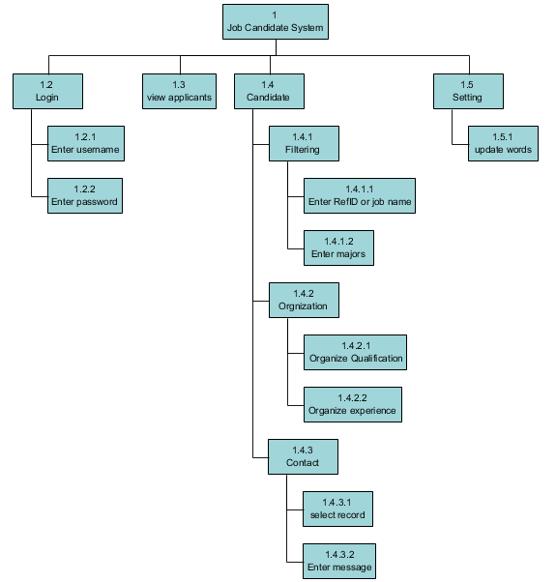

Figure 2.1: Functional Decomposition Diagram for JCS

* + 1. **Data Flow Diagram (DFD)**

The Data Flow Diagram (DFD) is the graphical representation of the processes and the flow of data among them [7]. A data flow diagram illustrates the process, data store, external entities and the connecting data flows in a system [6]. It is a common practice to draw a context-level Data Flow Diagram first which shows the interaction between the system and outside entities. This context-level DFD is then ˮ exploded ˮ into a detailed DFD. There are four components for a Data Flow Diagram. They are:

* External Entities Terminators are outside of the system being modeled. They represent where information comes from and where it goes. These are represented by rectangles.
* Processes, usually represented by an ellipse circle, which modify the input to generate the output.
* Data Stores represents a place in the process where data rests. This is represented by and open-ended rectangles or a cylinder symbol.
* Data Flows, represented by arrows, are how data moves between terminators, processes, and data stores.

Figure 2.2 represent Data flow Diagram for the project.

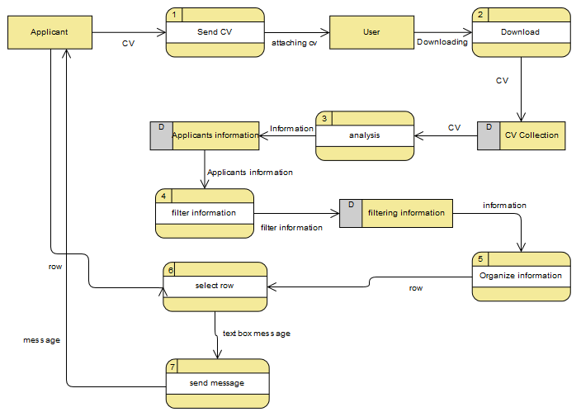

Figure 2.2: Data flow Diagram level 0

* 1. **Use Case Diagram (UCD)**

Use Case Diagram (UCD) in the Unified Modeling Language (UML) is a type of behavioral diagram created by use-case analysis and description. Its purpose is to present a graphical overview of the functionality provided by a system in terms of actors, their goals (represented as use cases), and any dependencies between those use cases [10].

The main purpose of a use case diagram is to show what system functions are performed for which actor. Roles of the actors in the system can be depicted. Interaction among actors is not shown on the use case diagram. If this interaction is essential to a coherent description of the desired behavior, perhaps the system or use case boundaries should be examined. Alternatively, interaction among actors can be part of the assumptions used in the use case. There are three main components for a use case Diagram. They are:

1. Use Cases: A use case describes a sequence of actions that provide something of measurable value to an actor and is drawn as a horizontal ellipse.
2. Actors: An actor is a person, organization, or external system that plays a role in one or more interactions with the system.
3. System Boundary Boxes (optional): A rectangle is drawn around the use cases, called the system boundary box, to indicate the scope of the system. Anything within the box represents functionality that is in scope and anything outside the box is not. Figure 2.3 shows the use case diagram to the application:

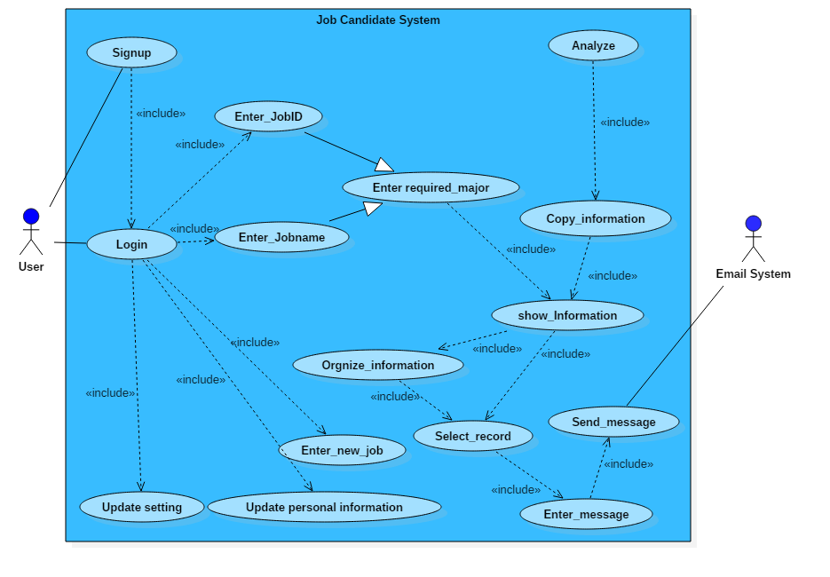

Figure 2.3: Use Case Diagram

Table 2.2 show description for each use case in Figure 2.3.

Table 2.2: Use case description

|  |  |  |  |  |
| --- | --- | --- | --- | --- |
| ID | Use case name | Actors | Description | Pre-condition |
| 1 | Login | User | The user Login to the system | The user must enter correct user name and password |
| 2 | Analyze | System | The system must analyze the CV sent line by line and word by word | The applicant must send CV to the system |
| 3 | Copy_information | System | The system must store the CV information on a database. | The system must analyze the CV sent line by line and word by word |
| 4 | Enter_JobID | User | The user enter JobID in system | The user Login to the system |
| 5 | Enter_Jobname | User | The user enter Jobname in system | The user Login to the system |
| 6 | Enter required_major | User | The user enter Jobname in system | The user enter JobID or Jobname |
| 7 | Show_information | System | The system displays the information in the database | The user enter Jobname in system |
| 8 | Orgnize_information | System | The system arrange the information copied from the CV based on the major's specialization, previous experience and qualification in order to facilitate access to the privileged persons. | The system displays the information in the database sending CV |
| 9 | Select_record | User | The user must specify the appropriate person row for the interview. | The system arrange the information copied from the CV based on the major's specialization, previous experience and qualification in order to facilitate access to the privileged persons. |
| 10 | Enter_message | User | The user send a message to candidate person about the date and place of the interview. | The user must specify the appropriate person row for the interview. |
| 11 | Send_message | System | The system sends the message written by the user to the person specified by the user | The user send a message to candidate person about the date and place of the interview. |
| 12 | Enter new job | User | The user can enter new job to system | The user must enter ID and name to job |
| 13 | Update personal information | User | The user can change his name , password or email | The user Login to the system |
| 14 | Update Setting | User | The user can change the words used to analyze the CVs | The user Login to the system |
| 15 | Signup | User | The user can sign up to the system | The user must enter unique user name, password and Email Address |

* 1. **Activity Diagram**

Activity diagram is a kind of behavioral specification. It is quite suitable to specify workflows or complex algorithms. Activity diagram is flow of functions without trigger (event) mechanism, consist of activities, states and transitions between activities and states [9]. Figure 2.4 shows the activity diagram to the application:

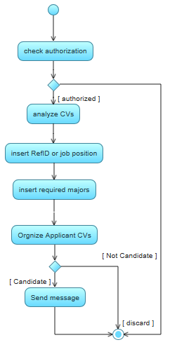

Figure 2.4: Activity diagram

* 1. **Data Model**

A Data modeling is performed during the initial phases of the database development process. The data modeling focuses mainly on what information should be stored in the database [8]. The information needed to build the data model is gathered during the requirement analysis. A comprehensive data model should take into account the current and future needs of an organization in order to support the business process within an organization.

To develop an effective application for Jobs candidate system, a consulting firm must maintain accurate and up to date information about jobs and Information for all people who have presented to jobs. In order to accommodate the above requirements a data model must be designed that captures the essential entities and relationship that are present in a Job candidate system.

* + 1. **Entity Relationship Diagram (ERD)**

An Entity Relationship Diagram (ERD) gives a graphical representation of the tables (entities) in the database and the relation between them [8]. The entities are represented by a rectangle, while a diamond represents the relation between them and a diamond within a rectangle represents an associate entity. The cardinality is the frequency of a relationship between two entities. Figure 2.5 shows the ERD for the project, in this ER diagram there is relationship between Applicant and job named (request), and it is many to many:

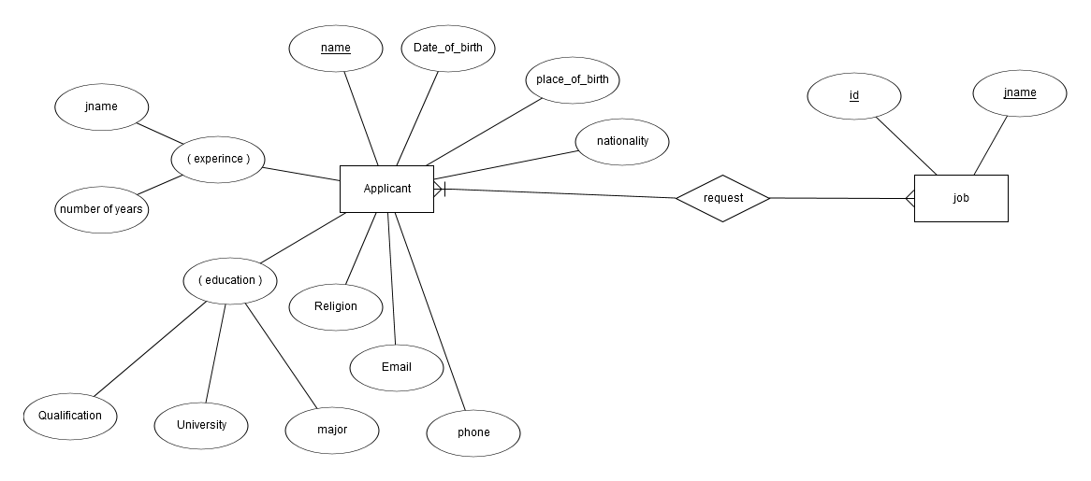

Figure 2.5: JCS ER Diagram

* + 1. **Database Design**

In the Relational Database, each of the entities including the associate entities is transformed into a table. The attribute (fields) of each of the entities for the ERD shown in Figure 2.5 are as follows, table 2.3 shows structure applicant and table 2.4 shows structure Job.

Table 2.3: APPLICANT

|  |  |  |  |  |
| --- | --- | --- | --- | --- |
| **NO** | **NAME** | **DATA TYPE** | **WIDTH** | **CONSTRAINTS** |
| 1 | name | TEXT | 40 | PRIMARY KEY |
| 2 | Date_of_Birth | TEXT | 15 | DEFAULT NULL |
| 3 | Place_of_birth | TEXT | 30 | DEFAULT NULL |
| 4 | Nationality | TEXT | 15 | DEFAULT NULL |
| 5 | Phone | TEXT | 15 | NOT NULL |
| 6 | Email | TEXT | 30 | NOT NULL |
| 7 | Religion | TEXT | 15 | DEFAULT NULL |
| 8 | Qualification | TEXT | 3 | NOT NULL |
| 9 | University | TEXT | 40 | DEFAULT NULL |
| 10 | major | TEXT | 20 | NOT NULL |
| 11 | id | TEXT | 9 | PRIMARY KEY |
| 12 | number_of_year | INTEGER | 2 | DEFAULT NULL |

Table 2.4: Job

|  |  |  |  |  |
| --- | --- | --- | --- | --- |
| **NO** | **NAME** | **DATATYPE** | **WIDTH** | **CONSTRAINTS** |
| 1 | id | TEXT | 9 | PRIMARY KEY |
| 2 | jname | TEXT | 20 | NOT NULL |

In the database, two tables were used as a data source. Table 2.5 shows structure the library to accept the new titles in CV, table 2.6 shows structure users information.

Table 2.5: Library

|  |  |  |  |  |
| --- | --- | --- | --- | --- |
| **NO** | **NAME** | **DATATYPE** | **WIDTH** | **CONSTRAINTS** |
| 1 | Title | TEXT | 15 | PRIMARY KEY |
| 2 | words | TEXT | 250 | NOT NULL |

Table 2.6: users

|  |  |  |  |  |
| --- | --- | --- | --- | --- |
| **NO** | **NAME** | **DATATYPE** | **WIDTH** | **CONSTRAINTS** |
| 1 | Username | TEXT | 30 | PRIMARY KEY |
| 2 | Password | TEXT | 30 | NOT NULL |
| 3 | Email | TEXT | 30 | NOT NULL |

* 1. **Sequence Diagram**

A sequence diagram in a Unified Modeling Language (UML) is a kind of interaction diagram that shows how processes operate with one another and in what order. It is a construct of a message sequence chart [11]. A sequence diagram shows object interactions arranged in time sequence. It depicts the objects and classes involved in the scenario and the sequence of message exchanged between the objects needed to carry out the functionality of the scenario. Sequence diagrams typically are associated with use case realizations in the logical view of the system under development.

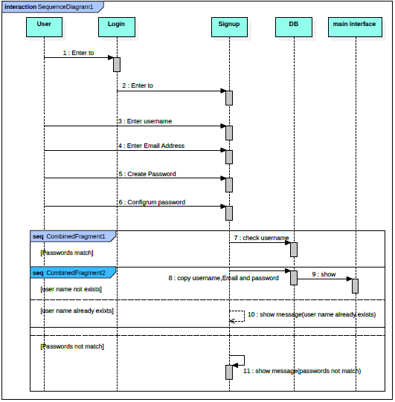

Figure 2.6: sequence diagram for Signup

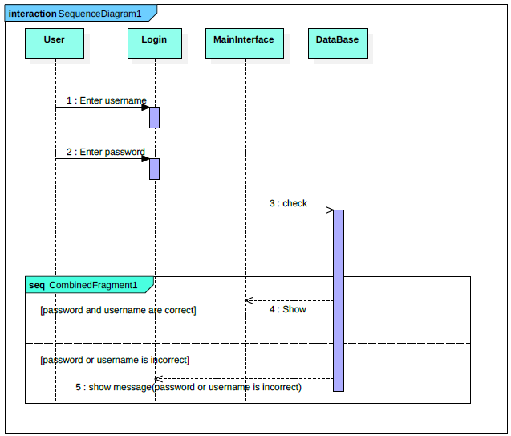

Figure 2.7: sequence diagram for Login

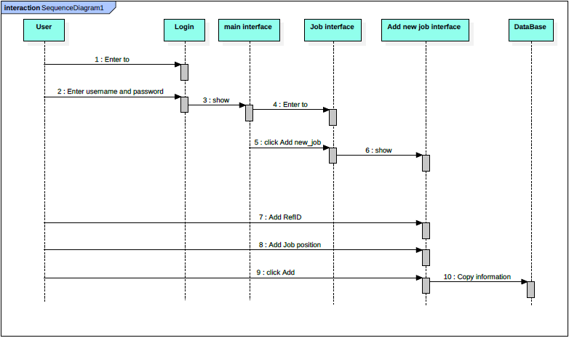

Figure 2.8: sequence diagram for Add new job

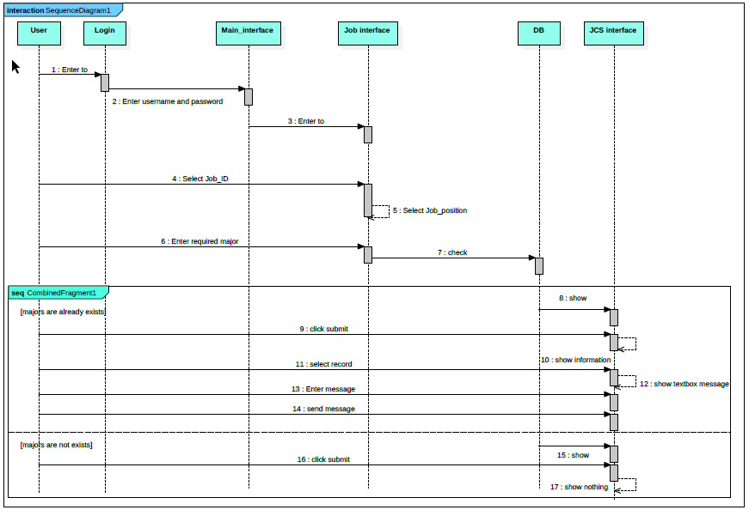

Figure 2.9: sequence diagram for Candidate

* + 1. **Usage and Limitations**

Some systems have simple dynamic behavior that can be expressed in terms of specific sequences of messages between a small, fixed number of objects or processes. In such cases sequence diagrams can completely specify the system’s behavior. Often, behavior is more complex, e.g. when there are many branch points (e.g. exceptions), when there are complex iterations, or synchronization issues such as resource contention. In such cases, sequence diagrams can completely describe the system’s behavior, but they can specify typical use cases for the system, small details in its behavior, and simplified overviews of the behavior.

**Chapter Three**

**Development and Testing**

* 1. **Introduction**

In development this project, a set of programs and software were used such as in python programing languages using JetBrains PyCharm IDE, DB Browser for SQLite for Database.

* 1. **Software**

In Design the Diagrams in this project, a set of programs and Software were used such as:

1. Microsoft office project: Microsoft project provides project management tools to manage projects, this program helped on organize work to make sure that project are completed on schedule.
2. StarUML: StarUML is visual processor used to create flowcharts, organization charts, mind maps, project and other visuals, this program helped on create some of diagrams for the project.
3. Dia: Dia is inspired by the commercial Windows program 'Visio,' though more geared towards informal diagrams for casual use. It can be used to draw many different kinds of diagrams. It currently has special objects to help draw entity relationship diagrams, UML diagrams, flowcharts, network diagrams, and many other diagrams.
4. ERD plus : A database modeling tool for creating Entity Relationship Diagrams, Relational Schemas, Star Schemas, and SQL DDL statements.

In Design the User Interface in this project, a set of programs and Software were used such as:

1. PyQt Designer: PyQt is a set of Python v2 and v3 bindings for The Qt [12].The PyQt installer comes with a GUI builder tool called Qt Designer. Using its simple drag and drop interface, a GUI interface can be quickly built without having to write the code. It is however, not an IDE such as Visual Studio. Hence, Qt Designer does not have the facility to debug and build the application.
2. Hypertext Markup Language (HTML)
   1. **Project process**

The JCS project selects the appropriate candidate for the job from among a group of applicants through several operations. Initially, the JCS project extracts full CV information from files that have extension docx or pdf and copied in txt files, then analyze each file by reading the file line by line where the line is divide into words and these words are compared to the attributes of the applicant , once they match the information is obtained information about applicant, for example to extract the phone of the applicant from the CV , the application read all the lines and divided each line into words and a comparison of each word in the line with “phone” word and all synonyms (PHONE, Phone, Telephone, etc.) , once a match is obtained, the applicant's phone is obtained by copying- information after a phone word. This process is applied to extract the rest of the information with certain constraints to extract some information. This process is executed on the rest of the CVs for extract all applicant information. This information is then classification by the job and majors entered by the user. The user selects the job from the combo box and enter the required majors in a textbox. The system analyzes the contents of the textbox by dividing contents the textbox into words and comparing these words with the extracted majors Of the CV and located in the database to be followed by the show of applicants information of the CVs based on majors and job in a table, and is organized this information through the order of the table according to the years of experience and by qualification, then the user can send a message to the person Required in the table.

* 1. **Screens of System**

1. The Following figure represent user Information in login information screen must be enter User name and Password even you can login to the system. see Figure 4.1

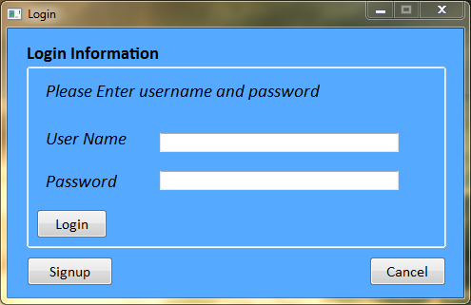

Figure 4.1: user Information screen

1. Following figure represent the sign up screen you must enter unique user name, password and Email Address. See Figure 4.2

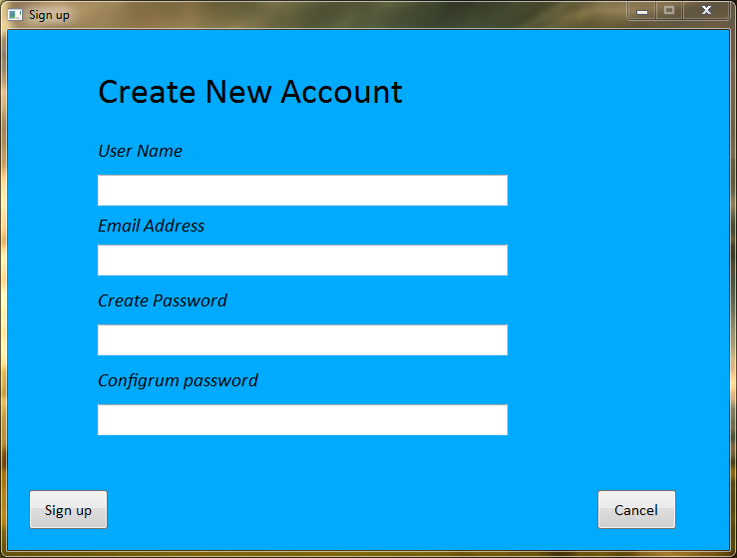

Figure 4.2: Sign up screen

1. Following figure represent the main screen that displays all system components. see Figure 4.3

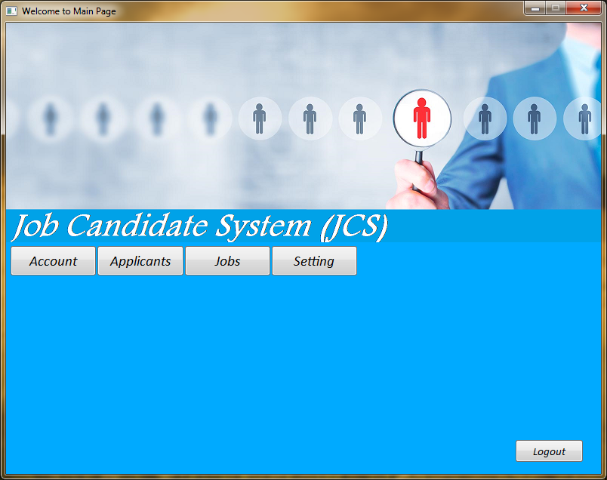

Figure 4.3: Main screen

1. Following figure represent the applicants Screen that displays the names of all employees are displayed with the selected job. see Figure 4.4



Figure 4.4: Applicants screen

1. Following figure represent the Jobs screen that Include (RefId, Job position, Number of applicants and required major). see Figure 4.5

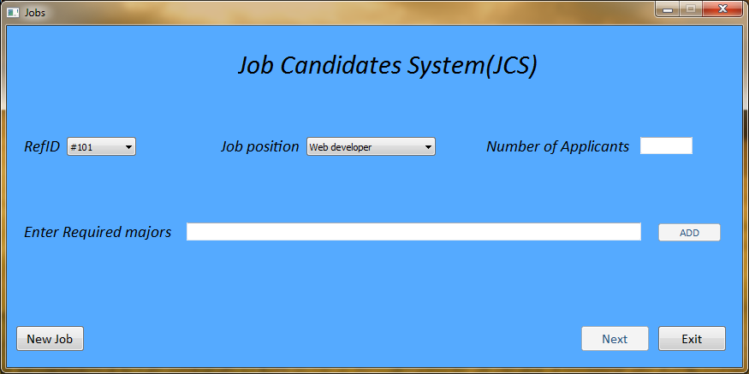

Figure 4.5: Jobs screen

1. Following figure represent the Add new Job screen Include (RefID and Job position) to add new job. see Figure 4.6

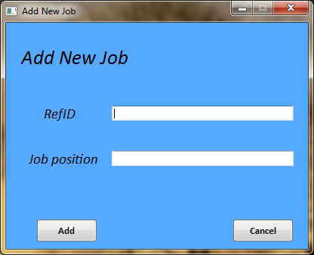

Figure 4.6: Add new Job screen

1. Following figure represent the JCS screen that display all applicants based on (job and major) that determined in the jobs screen. A person chosen for the interview is also contacted in this screen. see Figure 4.7

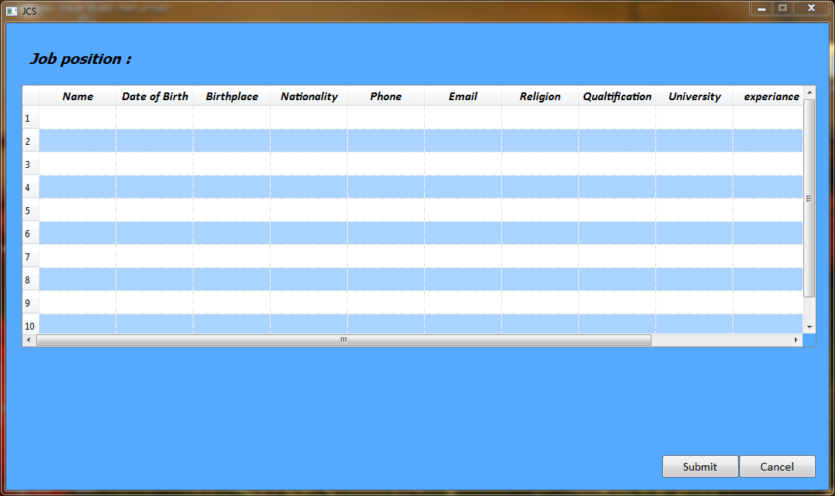

Figure 4.7: JCS screen

1. Following figure represent the Setting screen (library) that display all the words used to analyze the CVs with the possibility of updating. see Figure 4.8

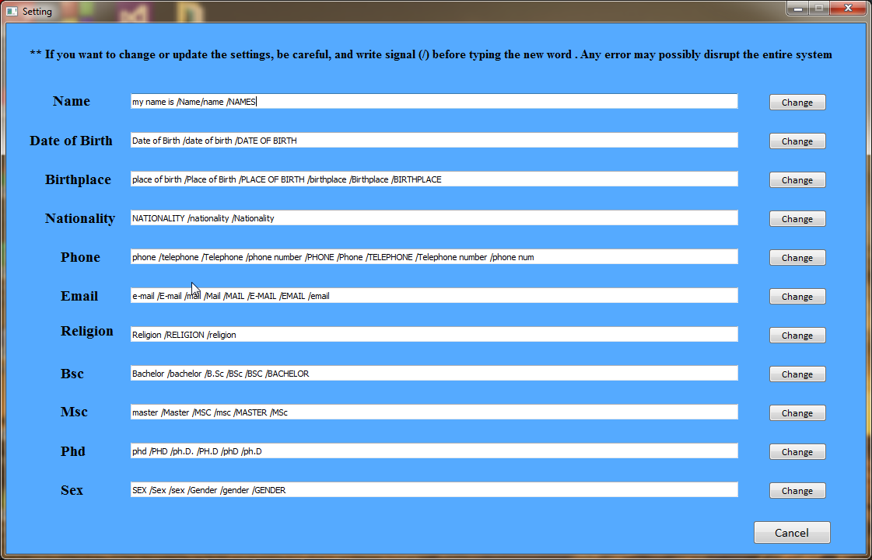

Figure 4.8: Setting screen (library)

1. Following figure represent the personal information Screen that displays all user information and the user can modify this information. see Figure 4.9

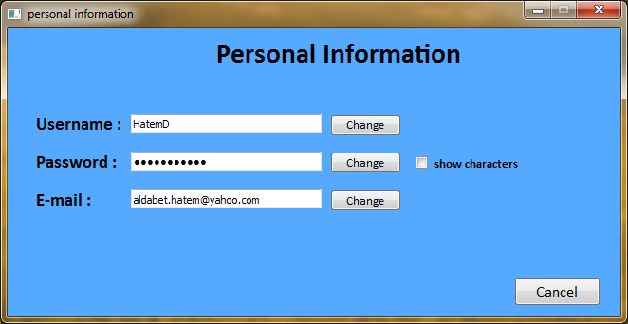

Figure 4.9: user information screen

**3.5 Testing**

Testing is finding out how well something works. In computer hardware and software development, testing is used at key checkpoints in the overall process to determine whether objectives are being met [10]. This application was tested in several stages. The first stage was the unit test. After the completion of the development of each system component, it was tested directly. In the beginning, the login component was tested by entering several different test cases in textboxes user name and password, the component was not affected by any of the test cases.

Several test cases were also enter in the Sign up component, the component was not affected by any of the test cases. In the Candidate component, about 100 different CVs were enter, of which about 90 were fully analyzed and about 10 were partially analyzed.

Then in integration testing stage, the system was fully tested by several users and they found that the system is working successfully and easy to use. At the verification stage it was confirmed that all the requirements in the table have been successfully implemented.

**Chapter Four**

**Conclusion and Future Work**

* 1. **Conclusion**

The proposed system (JCS) in the development stage is able to analyze the CVs and extract the important information from them and save this information in a database and then classify this information according to the functions and specialties defined by the user and organize this information according to the number of years of experience and by degree, The user can also identify the most suitable candidate and send him a message about the date and place of the interview. The use of this system and its development in the companies can solve even part of the problem of manual filtering, which consume a lot of time and cause many problems in companies.

* 1. **Future Work**

My hope in the future on the:

* Analyze CVs in different written languages.
* Add module chat to the system.
* Apply the system in my University.

**References**

[1] https://en.wikipedia.org/wiki/Project_planning

[2] System Analysis and Design, Ninth Edition, "Gary B. Shelly" and "Harry J. Rosenblatt", 2012

[3] <https://www.sqlite.org/about.html>

[4] <https://en.wikipedia.org/wiki/Systems_design>

[5] Requirements Engineering A good practice guide, Ramos Rowel and Kurts Alfeche, John Wiley and Sons, 1997

[6] Teaching Functional Decomposition For The Design Of Electrical And Computer Systems, Chris Coulston and Ralph M. Ford, November 2004

[7] System analysis & Design, Fifth Edition, ALAN DENNIS, BARBARA HALEY WIXOM, ROBERTA M. ROTH , 2012

[8] Introduction to Data Modeling and MSAccess, Jelena Mamčenko, Vilnius Gediminas Technical University, 2004

[9] On the role of activity diagrams in UML, Barbara Paech, Universität Heidelberg, 2015

[10] The Role of “Roles” in Use Case Diagrams, Alain Wegmann, Guy Genilloud, Institute for computer Communication and Application (ICA), Swiss Federal Institute of Technology (EPFL)

[11] On the Role of Activity Diagrams in UML, B. Paech, Institut für Informatik, Technische Universität München

[12] https://wiki.python.org/moin/PyQt

**Appendix A**

**System Screens**

In this Appendix I will give a series of screens in my application with an explanation for each screen.

1. Login Information: enter user name and password.

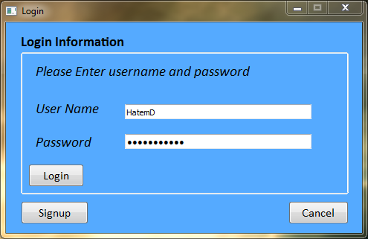

1. If new user enter to system he can sign up to system by clicked signup in Login screen then enter username, password for he and his email.

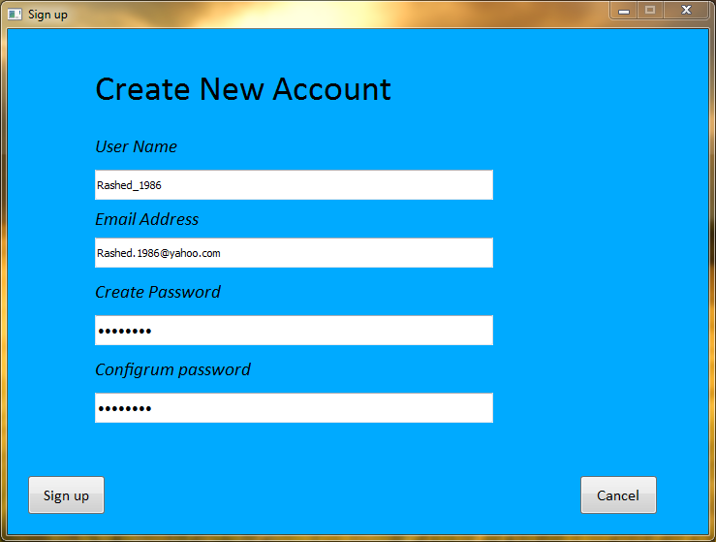

1. Main Screen: After typing the user name and password correctly, the Main screen appears and displays all system components.



1. Personal information screen: All user information is displayed and the user can modify this information.



1. Applicants screen: the names of all employees are displayed with the selected job.

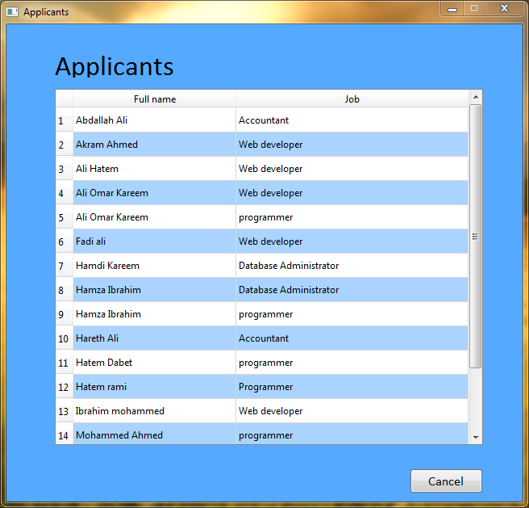

1. Job screen: Include (RefId, Job position, Number of applicants and required major) to analysis applicants.

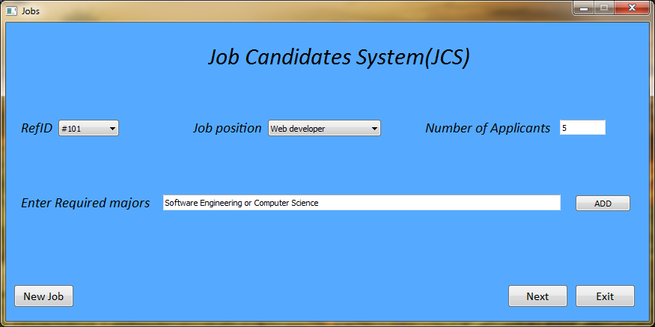

1. Add New Job screen: Include (RefID and Job position) to add new job.

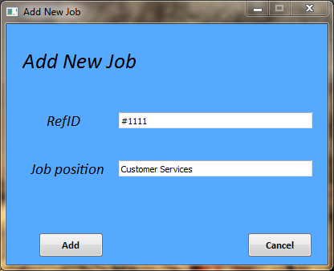

1. JCS screen: All applicants are displayed based on the job and major that determined in the jobs screen. A person chosen for the interview is also contacted in this screen.

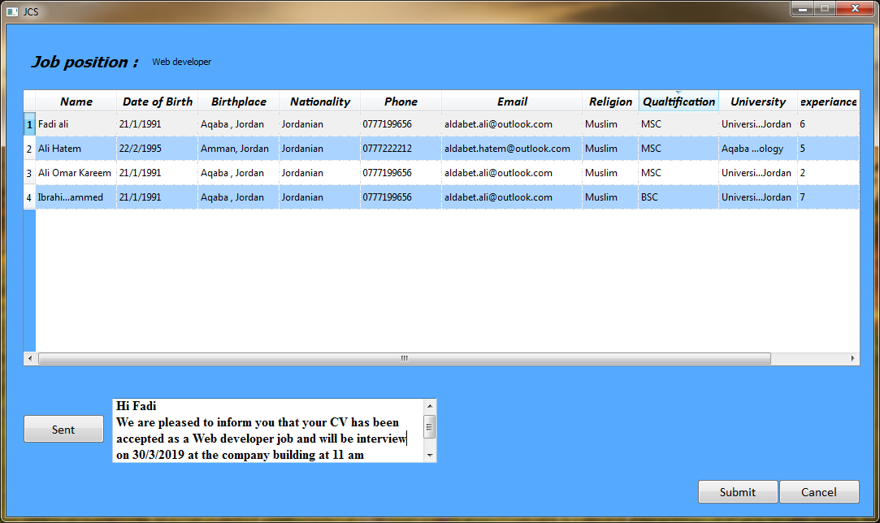

1. Setting screen: Displays all the words used to analyze the CVs with the possibility of updating.

